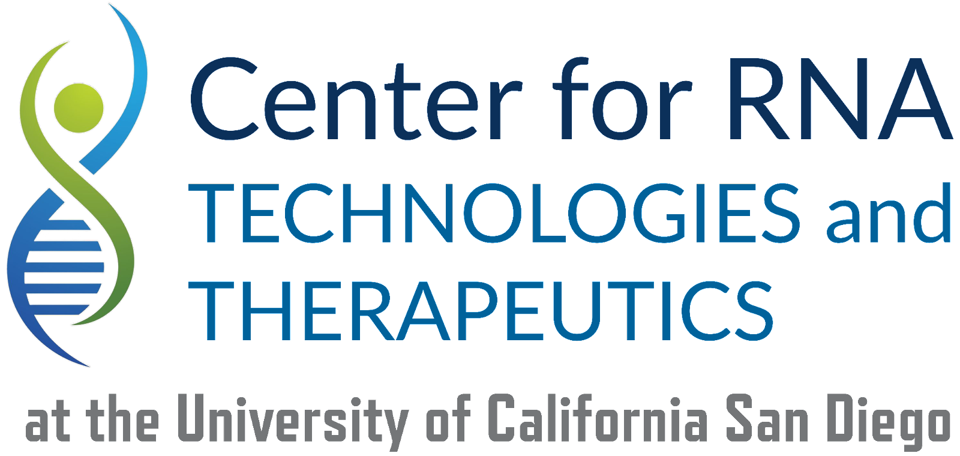

Please contact **rna-center@ucsd.edu** to discuss your project with the Center for RNA Technology and Therapeutics staff before submitting samples.

Once you have spoken to Center staff and are ready to submit samples, please:

(1) Ensure that your samples are prepared according to the guidelines discussed.

(2) Complete sample manifest (download a blank copy [here](https://docs.google.com/spreadsheets/d/1SSAqyfUTZz35PZHmbyMqykou0PKfEL-2Z5vOdbVnhcY/edit#gid=0)).

• Please be sure to complete all fields in the “Samples” tab.

• Please be sure that your samples are in 1.5 mL tubes clearly labeled with the same Sample ID as indicated on your sample submission form.

• Please also label the side of the tubes with your last name.

(3) Send manifest to rna-center@ucsd.edu with the subject line: “CLIP sample manifest - [your last name here].

(4) Please drop samples off Monday-Thursday between 10 am-4 pm at our drop-off freezer.